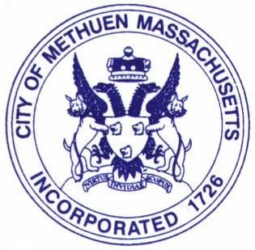
City of Methuen, Massachusetts
OFFICE OF THE CITY COUNCIL
PUBLIC SAFETY COMMITTEE
The Searles Building • 41 Pleasant Street
Methuen, Massachusetts 01844

TELEPHONE (978) 983-8510 • FAX (978) 983-8975

Public Safety Committee Membership:
Joel Faretra, Central District City Councilor
Nicholas DiZoglio, City Councilor At-Large
Allison Saffie, West District City Councilor

Methuen City Council – Public Safety Committee Meeting
Monday, July 7th @ 6:00pm at City Hall in the Great Hall, 3rd floor

Agenda

- Roll Call
- Acceptance of the Agenda
- Public participation
- Acceptance of previous meeting minutes
  - none
- Old business
  - 25 MPH ordinance-update on funding and the plan to proceed with procurement and installation of signs
  - Follow up on email from MassDOT-Councilor DiZoglio
  - Snow emergency ordinance- will it be updated for the winter?
- New business
  - Do not knock ordinance updates
  - Safe Streets committee meetings?
  - Public safety outreach programs and implementation - Councilor Saffie
- Set date for next meeting
  - September 15th @ 6pm
- Adjourn
Respectfully Submitted,
Committee Chair Joel Faretra

